Vindhya Meda

SQL QUESTIONNAIRE

1.Select top 10 records from Employee table where Emp_Sal > 10000

Answer:

SELECT *

FROM Employee

WHERE Emp_Sal>10000

ORDER BY Emp_Sal DESC

LIMIT 10;

DEMO on SQL-

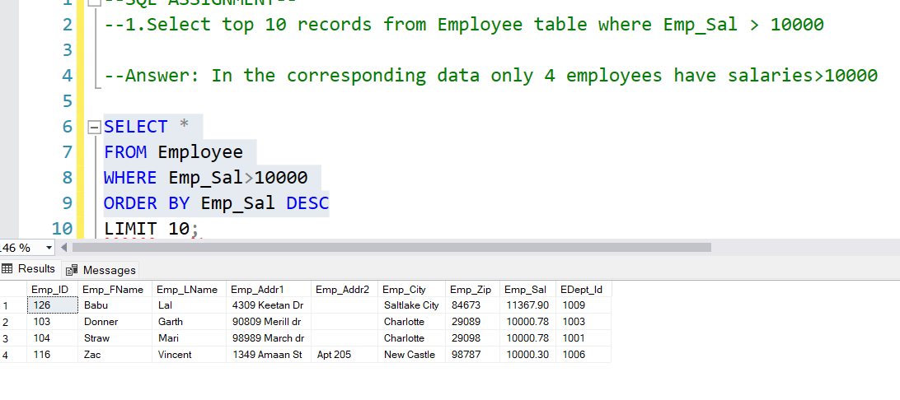

------------------------------------------------------------------------------------------------------------------

2.Retrieve Emp_Id, Emp_FName, Emp_Addr1, Emp_City, Emp_Zip, Dept_Name, Dept_City

From Employee whose Department City is Brentwood. Use Table Alias

Answer:

SELECT E.Emp_Id, E.Emp_FName, E.Emp_Addr1, E.Emp_City, E.Emp_Zip, D.Dept_Name, D.Dept_City

FROM Employee E

JOIN Department D

ON E.Emp_Id = D. Emp_Id

WHERE D.Dept_City LIKE 'Brentwood';

---------------------------------------------------------------------------------------------------------------

3.Retrieve Emp_ID, Emp_Fname, Emp_Zip from Employee who are all working in department HR&Training and Compliance. Use embedded SQL statements

Answer:

SELECT Emp_ID, Emp_Fname, Emp_Zip

FROM Employee

WHERE Emp_ID IN

(SELECT Dept_Name

FROM Department

WHERE Dept_Name LIKE 'HR&Training', 'Compliance');

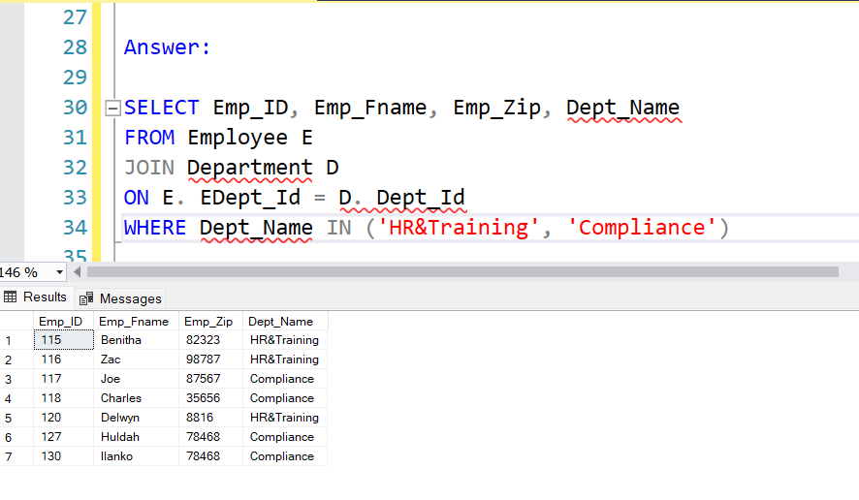

--------------------------------------------------------------------------------------------------------------

4.Retrieve Sum(Emp_Sal) and Dept_Name from Employee and Emp_Department by Dept_Name (Group By)

Answer:

SELECT SUM (E.Emp_Sal) AS Total_Salary, Dept_Name

FROM Employee E

JOIN Department D

ON E.EDept_ID = D.Dept_Id

WHERE D.Dept_Name IN ('HR&Training', 'Compliance')

GROUP BY Dept_Name

ORDER BY Total_Salary DESC

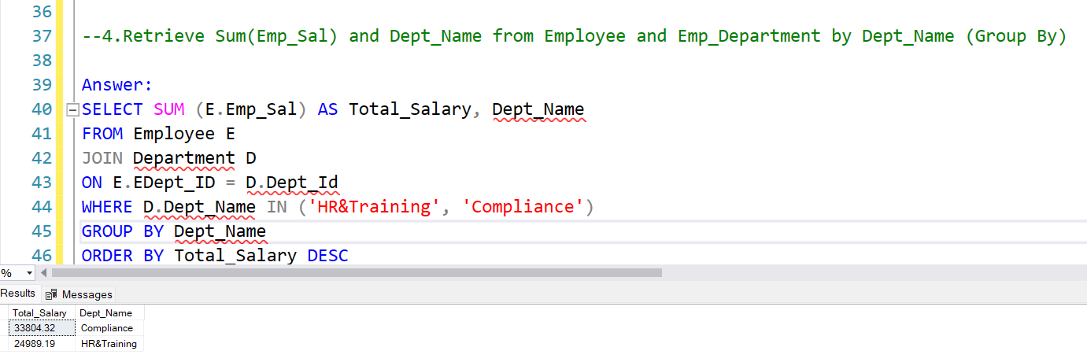

------------------------------------------------------------------------------------------------------------------

5.Select 2nd highest sal from Employee table

Answer:

SELECT Emp_Sal

FROM Employee

ORDER BY Emp_Sal DESC

SELECT Emp_Sal

FROM Employee

WHERE Emp_Sal=10000.78

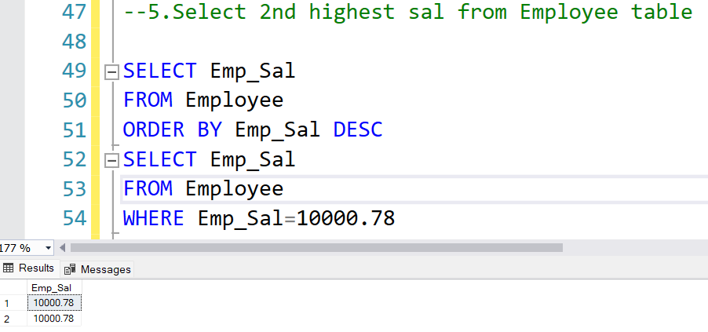

--OR USING MAX

SELECT MAX(Emp_Sal) AS '2ndhighestSal'

FROM Employee

WHERE Emp_Sal < (SELECT MAX(Emp_Sal) AS '1sthighestSal' FROM Employee);

------------------------------------------------------------------------------------------------------------------

6. Rename a column Person_Name to P_Name in the table Person

Answer:

Exec sp_rename 'dbo.Person.Person_Name', 'P_Name', 'COLUMN';

------------------------------------------------------------------------------------------------------------------

7.List down all the SQL constraints

Answer:

PRIMARY KEY

FOREIGN KEY

UNIQUE

NOT NULL

DEFAULT

CHECK

8. Retrieve Emp_Id, Emp_FName, Emp_LName for location Zip_Code 88160 (use all three Employee tables) Use Embedded sql statements

Answer:

SELECT E.Emp_Id, E.Emp_FName, E.Emp_LName

FROM EmpTable1 E1

JOIN EmpTable2 E2

ON E1.Dept_ID = E2.Dept_ID

JOIN EmpTable3 E3

ON E1.Emp_ID= E3.Emp_ID

WHERE E1.Zip_code = 88160;

----------------------------------------------------------------------------------------------------------------

9. Write a query using Right Outer join to retrieve the data from Employee and Emp_Department table

Answer:

SELECT *

FROM Employee

RIGHT OUTER JOIN Emp_Department

ON Employee.EDept_ID = Emp_Department.Dept_ID

--Or aliases can also be assigned as below--

SELECT *

FROM Employee E

RIGHT OUTER JOIN Emp_Department D

ON E.EDept_ID = D.Dept_ID

29 rows returned

Record for Emp_ID 129 does not pull up here since this record has NULL values under Dept_Name, Dept_City, Dept_State as seen in question 10 below.

------------------------------------------------------------------------------------------------------------------

10. Write a query using Full Outer join to retrieve the data from Employee and Emp_Department tables

SELECT *

FROM Employee E

FULL OUTER JOIN Emp_Department D

ON E.EDept_ID = D.Dept_ID

30 rows returned

------------------------------------------------------------------------------------------------------------------